Demo Script

**...\>** py -m venv project-name

**...\>** project-name\Scripts\activate.bat

**...\>** django-admin startproject mysite

**...\>** py manage.py runserver

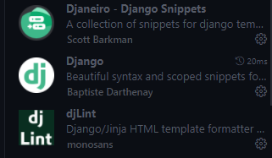

* **Set up database**

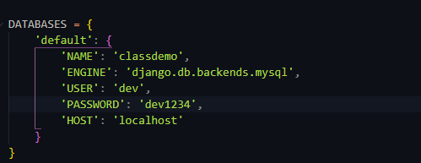

**...\>** py manage.py startapp students

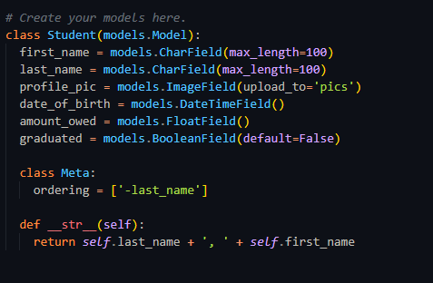

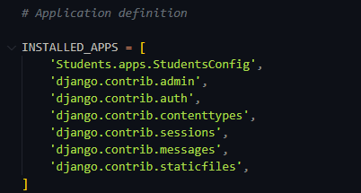

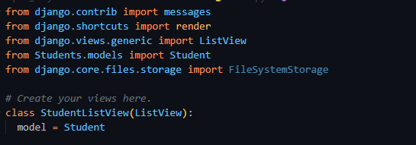

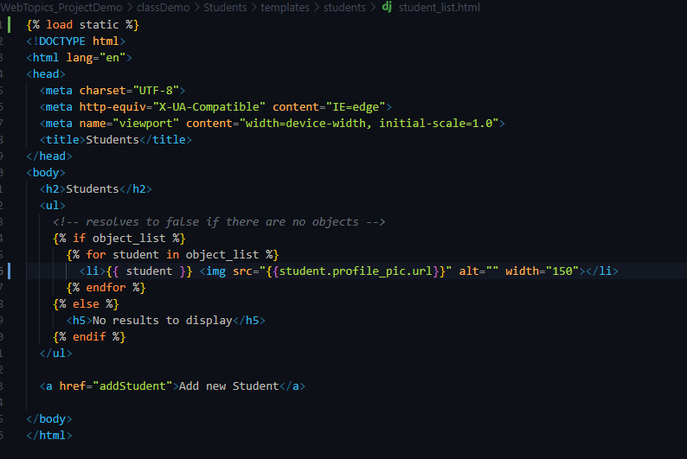

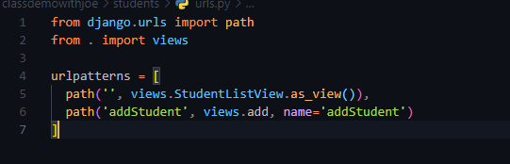

Statics!

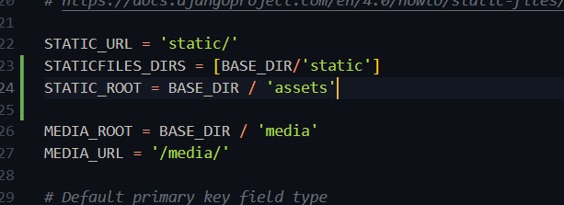

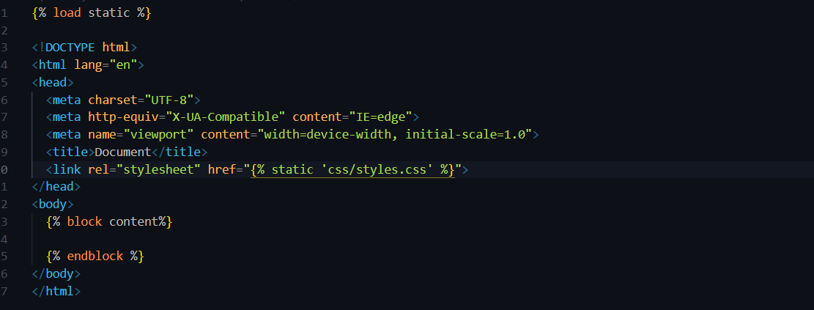

* Py manage.py makemigrations [--name] [RequestedName]
* Py manage.py migrate